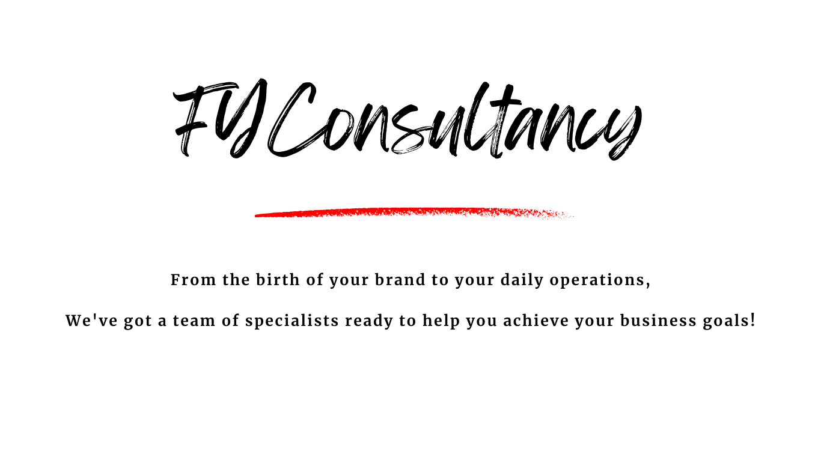

Business Guide - The Knowledge Book of Business

FYConsultancy’s Start Up Guide

Market Research - The first step after you’ve settled on an idea to bring to life.
- Complete detailed market research on the products or services that you are wanting to provide – Work out who your target audience is, how much they will want to spend on your products or services, how they want to buy your products and services.
- Check out your competitors, see what products or services they are offering, how much are they charging, where they are advertising.

Your business plan, writing it down on paper (or on a computer) – No-one knows your business idea better than you; it is always useful to have it written down, so you don’t forget crucial points and you can also look back at your business plan to keep your company on the right track. You will need a professional, written, or printed business plan if you decide to apply for business financing.
- Executive Summary – This should be a quick summary of your business plan, including important information such as your business goals and objectives, along with the problem your business products or services are solving.
- Company Description – Summarise your company, it’s purpose and what makes it unique.
- Products and Services – Detail what your business will make or provide, go through pricing and benefits consumer by using your product or service.
- Market Analysis – In this section you can write about you market research findings, your expected demographic and market audience.
- Strategy and Implementation – Discuss the company’s mission, it’s key values and the areas of focus for the business, include any future projects that will boost your business, create objectives to maximise profitability and increase sales; describe how you will achieve these objectives.
- Organisation and Management Team – Write about your organisational structure and who does what in the workforce, detail how different roles will impact the business and utilise experience when recruiting for these positions. Discuss your directors and senior management team, including qualifications and experience that make them suitable for your leadership team.
- Financial Plan and Projections – In this section you would talk about your company projections, cash flow forecasts, initial and ongoing funding sources, and ways your business will be self-sustaining in terms of income.

Register your business – Whether you are wanting to trade as a sole trader, partnership, or Limited Company, you will need to register your business before you start trading.
You can register your business yourself via the gov.uk website, or if you have chosen an accountant or formation company to work with already, they can register the company for you. This will normally incur a fee. This fee will be explained to you by your accountant or the formation company beforehand.

Financing your business – That good old saying where you must spend money to make money is never more real than in the setup of a business.
There are so many financing options available for start-ups and ongoing support for established businesses. Government grants are available for new entrepreneurs, young entrepreneurs and niche businesses that improve the local community or provide a solution to a service demand. It is always worth searching online for funding options before anything else as you may be surprised what you can get funding for. It is always recommended that you discuss funding options with an accountant or a business funding consultant first to give you complete peace of mind and insight for your decision making.

Building your brand – Your brand is your vision being brought to life.
If your business needs a social media presence to promote and advertise then your social pages should be a true representation of your business. Your posts should be consistent, timely and appropriate. Double check for spelling mistakes, misprinted contact details or broken links.
If you are setting up a premises on a high street, you want to grab the attention of potential customers. Your shopfront will need to be appropriate for your type of business, engaging and captivating, and relevant to your products or services. Your premises should be inviting, and your staff (if any) should be professional and represent your brand as if it were their own. As everyone knows, people are more likely to voice a bad experience over a good one, so try to alleviate any issues before they happen.
Don’t forget about your personal brand! Your personal brand is the key to unlocking customer loyalty and trust! It's what sets you apart from the competition and makes your business shine. Working with financing companies, accountants, and business consultants to build a strong, authentic brand that reflects your values and personality, and attracts customers who love what you do can help elevate your business above the competition. Utilising their knowledge and experience can prove to be invaluable. If you believe in your brand, it will show.

Launching your business – When you are ready.
Only you can decide when the right time to launch your business is. Realistically you can launch a business at any of the previous stages, however, it will be difficult if you don’t have all your ‘ducks in line’ before you go live.
Once your business is operational, you want to focus on selling or providing a service, not worrying about how many products you need to sell to break even or finding a premises.
If you’re selling a product, you may decide that its best to hold a launch night to gather feedback on your products, pricing, and the experience. If you are providing a service, you may offer certain discounts for the first handful of customers such as no VAT payable for the first 5 clients, or a bundle package of services as a welcome.

FYConsultancy has various services offered on the website for Start-Up Branding, Social Media Creation, Business Operations Support and Business Growth Solutions.
We empower startup founders and business owners to achieve their goals by crafting tailored strategies for growth, profitability, and customer loyalty. From marketing campaigns to customer retention initiatives, we help you build a strong foundation for long-term success.
Regardless of the route you take to operational success FYConsultancy wishes you the very best in your new venture!

This document and all documents present on FYConsultancy website (www.consultancybyfy.co.uk) and all company related social media pages, provide general information and discussion about business related subjects. The words and other content provided, including any linked materials, are not intended, and not to be construed as legal advice. If the reader or any other person has questions relating to legalities of creating, setting up or running a business, they should seek legal advice. FYConsultancy, employees of, directors of, or any persons of significant control, accept no liability for the information contained within. The information contained within has been provided as a rough guide to starting a business.

